**CS405 Machine Learning**

**Pre Lab #4 CNN**

**Pre Lab (25 points)**:

In this pre lab, it requires you to know about mnist dataset.

**MNIST Dataset Introduction:**

Most examples are using MNIST dataset of handwritten digits. The dataset contains 60,000 examples for training and 10,000 examples for testing. The digits have been size-normalized and centered in a fixed-size image (28x28 pixels) with values from 0 to 1. For simplicity, each image has been flatten and converted to a 1-D numpy array of 784 features (28*28).

**Overview:**

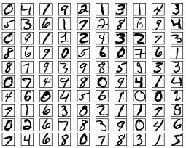

<http://yann.lecun.com/exdb/mnist/>

**Exercise:**

Two scripts will be provided. One is to download and process mnist dataset, another one is to build a multilayer perceptron to train the dataset.

* Make the scripts run, give the output
* Visualize loss, accuracy, computation graph, weights, gradients and activations by TensorBoard.
* Please explain loss function, SGD and Activation function.